## Tika Lal Taploo

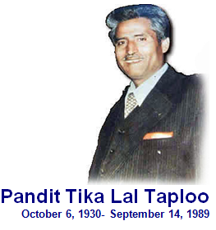

**About**: A man dedicated to a cause from childhood to the end unmoved by the threats and intimation allurements or allegation was born in 1930.   
Sh. Taploo joined Kashmir Bar in 1957, and since then had been working as an active Participant in Promotion of Justice. He was enrolled as an Advocate of high Court on April 1971. He was a social worker and was arrested six times as RSS activist. Got married to Smt.Sarla who was working as Govt. Teacher in 1957.Sh.Tikalal Taploo was one who Muslims more than Hindus and Hindus more than Muslims had to decades taken as their friend, sympathizer and benefactor.

In 1975 when the hag hands of internal Emergency had gripped the whole nation at its throat, on the call of Lok Sangagh Samiti formed by various national parties under the leadership of Lok Nayak Jaya Prakash Narayan Jee, TIKALAL courted arrest at historic Lal Chowk in Srinagar with three others colleagues.

It was not just a coincidence that Sh. Tika Lal ji was selected as the first target amongst lacks of Kashmiri Pundits.

**Murdered on:** 14 September 1989.

**Attack details:** He was attacked at his residence in Chinkral Mohalla, but came out openly and challenged the militants without any fear.

**Reason to him target:** Sh.Tika Lal Taploo was felled by the assassins, bullets in broad-day light outside his own house in Srinagar. The Islamic fundamentalists had murdered not only Taploo but also an old faith and culture of universal brotherhood and love and tolerance which be symbolized in his life.

**Occupation: :**  Tika Lal Taplo was a politician and rose to the high office of Vice President of Pradesh Bhartiya Janta Party and a lawyer.

**Belief:** Shri Taploo was an ardent champion of liberty and upholder of fundamental rights of the citizens.

**Educational details:** Tika Lal passed his Matriculation in 1945 from Punjab University and did his M.A.L.L.B from Aligarh Muslim University in 1958. He was ignored admission along with other Kashmiri Pundit’s but he started agitation and staged Dharna in front of the University campus along with other students till he was given admission. He completed his law in 1957.

**Reaction of local population:** Sh.Tikalal Taploo was one who Muslims more than Hindus and Hindus more than Muslims had to decades taken as their friend, sympathizer and benefactor.

**Link:**  <https://www.dailyexcelsior.com/tribute-to-tika-lal-taploo-2/>

